Arena specification
Autonomous multi-robot order fulfilment under congestion
Participant handout | Read this before you design your robot.
This document describes the floor you will compete on, the robots you may bring, and the API your software must speak. The arena is identical at every venue, so every dimension here is fixed.

1. The floor
You are working on a 3 m x 3 m floor, taped out on the ground in black insulation tape. Everything is flat. There are no physical shelves, walls, or obstacles anywhere on the arena, so nothing will physically stop your robot from driving somewhere it should not. The tape defines the rules and your robots are expected to obey it.
Two kinds of space. Shaded rectangles on the plan are keep-out zones. Treat them as solid shelving. Your robot must never cross one. Everything unshaded is navigable lane, and every lane on this floor is exactly 20 cm wide.
Lanes fit exactly one robot. A robot may be at most 15 cm wide, so a 20 cm lane admits one robot and no more. There is no wide spot, no passing bay, and no route across a block. Two robots can never pass each other anywhere on this floor. If two of your robots meet nose to nose, one of them is reversing.
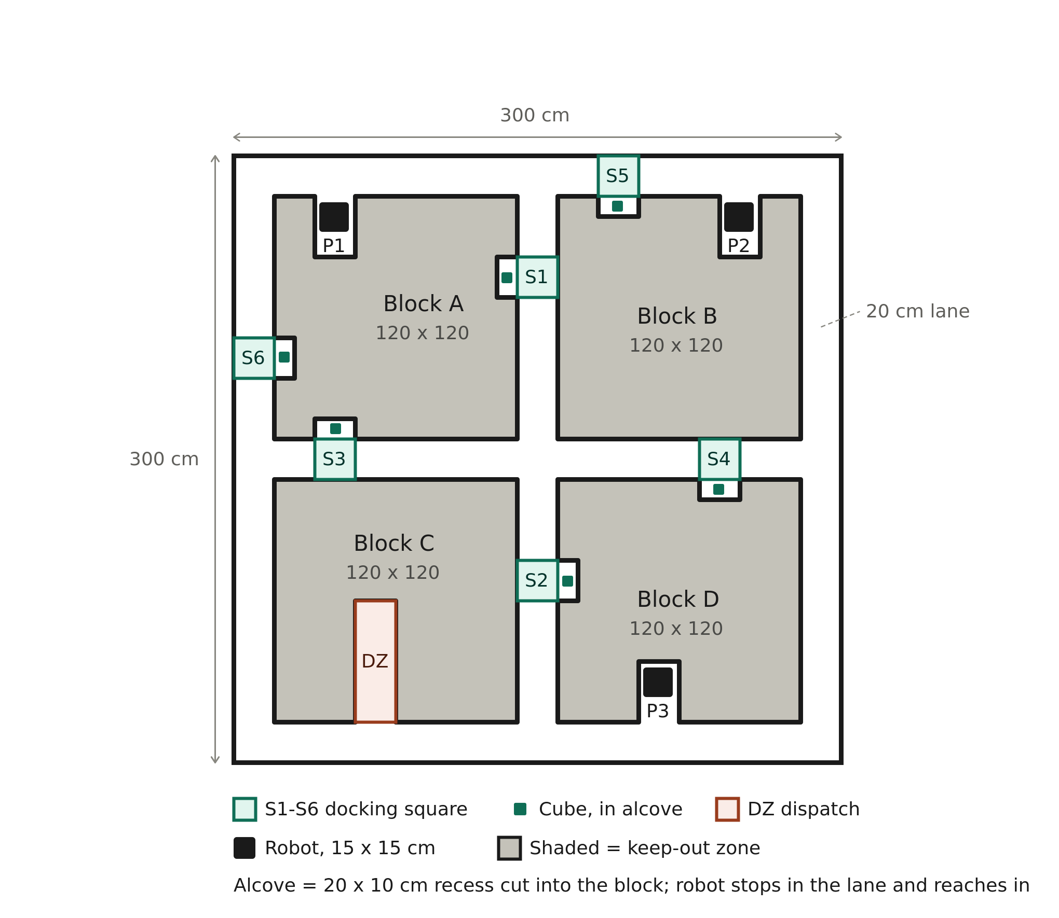
Figure 1. Arena floor plan. All dimensions in centimetres.

2. Layout
Four keep-out blocks, each 120 x 120 cm, are set 20 cm in from the outer boundary. The gaps between them form a perimeter ring running all the way round the floor, and a cross of two lanes meeting at a four-way junction in the dead centre.
That central junction is the busiest 20 x 20 cm on the arena. Most paths between opposite corners want to pass through it, and only one robot can occupy it at a time. The perimeter ring is the alternative route: longer, but it is a closed loop, which means three robots circulating on it with conflicting direction preferences can reach a state that no purely local rule will escape.

Pick stations, S1 to S6
Each station is two features working together.
- The alcove is a 20 cm wide by 10 cm deep recess cut into the keep-out block. The cube sits inside it, entirely clear of the lane.
- The docking square is the 20 x 20 cm marked square in the lane directly in front of the alcove. You drive onto it, reach into the alcove, take the cube, and drive off.
A waiting cube never blocks anything. A robot picking one blocks everything. While you are on a docking square, that lane is shut in both directions for as long as your gripper takes. Your pick duration is not merely a delay for you, it is a lane reservation held against the rest of your fleet, and your planner needs to model it as one.
Note where the stations are. S1 and S2 sit in the vertical cross lane, S3 and S4 in the horizontal cross lane, and S5 and S6 on the perimeter ring. S5 and S6 are the only two stations reachable without ever entering the cross. S1's alcove is cut into Block A on the west side of the vertical lane while S2's is cut into Block D on the east side, so robots servicing those two dock facing opposite walls, and if they approach from opposite ends they will meet nose to nose with cubes in hand.

Dispatch, DZ
A 20 x 60 cm dead-end bay cut into Block C, opening onto the bottom ring. Every order you fulfil ends here. It holds one robot, there is no room to turn around inside it, and the only way out is reverse. Every cube on the floor passes through this one bay, which makes it the hard ceiling on your throughput.

Parking, P1 to P3
Your three robots start in these bays and return to them when idle. Each is a 20 x 30 cm stub, also a dead end, also reverse-only. P1 and P2 both open onto the top ring, so those two robots contend with each other from the first second of the run. P3 opens onto the bottom ring.
Alcoves, parking bays and the dispatch bay are all the same kind of feature: a recess cut into a block, off the lane. The difference is depth. An alcove is 10 cm and you stay in the lane while you work. A parking bay is 30 cm and a dispatch bay 60 cm, so you drive fully in and must reverse out.

3. Fixed coordinates
Origin is the bottom-left corner of the taped floor. The x axis increases east, y increases north, and all values are centimetres. These are the centres of the docking squares and bays. The arena is identical at every venue.
Location | x (cm) | y (cm)
S1 docking square | 150 | 240
S2 docking square | 150 | 90
S3 docking square | 50 | 150
S4 docking square | 240 | 150
S5 docking square | 190 | 290
S6 docking square | 10 | 200
DZ drop point | 70 | 50
P1 parking | 50 | 265
P2 parking | 250 | 265
P3 parking | 210 | 35

4. Your robots
Constraint | Requirement
Fleet size | Exactly 3 robots. Fixed for the whole event.
Footprint | Maximum 15 x 15 cm.
Height | Maximum 20 cm.
Pick mechanism | Your own design. Must reach approximately 10 cm laterally from the docking square into the alcove.
Package | 4-5 cm cube with a QR code on at least one face.
Localization | Your choice. Onboard sensing, fiducial markers, or both.
Markers | Maximum 10 per team. Must be placed before challenge cubes are loaded.
Compute | Your choice, but constrained is rewarded. Preference order: edge device, then phone, then laptop on the venue LAN.

Hardware implication worth planning for early. Your pick mechanism needs roughly 10 cm of lateral reach from the docking square. You cannot pick a cube head-on at a station. Head-on approach only works at the parking and dispatch bays, which you drive into.

5. How an order works
A mock WMS pushes you a continuous stream of orders. Each names a station. You fetch the cube from that station's alcove and deliver it to DZ. Order rate and burst size increase as the run progresses. The fleet stays at three robots throughout, so difficulty comes from load, never from more hardware.
- Poll the WMS for open orders, or subscribe to the event stream.
- Assign the order to one of your robots and plan a route.
- Drive onto the station's docking square and pick the cube from the alcove.
- Read the QR code and report the pick, quoting the cube ID you read.
- Drive to DZ, enter the bay, release the cube, and report the delivery.
- Reverse out of the bay and take the next order, or return to a parking bay.

6. WMS API
HTTP and JSON over the venue LAN, so it works identically whether your stack runs on an edge device, a phone, or a laptop. The WMS runs on the organiser's machine and you will be given a base URL at the start of your run.
http://<wms-host>:8080
Every request carries your team token in a header:
X-Team-Token: <issued at check-in>
All timestamps are seconds elapsed since run start, as a float. All coordinates are centimetres in the frame defined in section 3.

GET /orders
Returns every order currently open for you. Poll as often as you like; 1 to 2 Hz is ample.
{
"t": 34.19,
"run_state": "running",
"orders": [
{
"order_id": "O-0007",
"issued_at": 31.02,
"station": "S3",
"cube_id": "C-17",
"destination": "DZ",
"priority": "normal",
"status": "pending"
}
]
}
The status field is one of pending, picked or delivered. Delivered orders drop off the list. priority is normal or urgent; urgent orders appear in later rounds and score more if delivered inside their window. run_state is waiting, running or finished. Do not move before running.

POST /orders/{order_id}/picked
Call this the moment the cube is in your gripper, not when you arrive at the docking square.
{ "robot_id": "R2", "cube_id": "C-17" }

200 OK
{ "ok": true, "order_id": "O-0007", "status": "picked", "t": 41.55 }
The cube_id must match the QR code you read off the cube. This is how we verify you picked the right one. A mismatch returns 409 and the order stays pending:
409 Conflict
{ "ok": false, "error": "wrong_cube", "expected": "C-17", "received": "C-09" }

POST /orders/{order_id}/delivered
Call this once the cube is released in the dispatch bay.
{ "robot_id": "R2" }

200 OK
{ "ok": true, "order_id": "O-0007", "status": "delivered",
"t": 58.31, "cycle_time_s": 27.29 }
Delivering an order you never picked returns 409 not_picked. Both POSTs are idempotent: a repeat returns 200 with "already_recorded": true, so a flaky network will not cost you an order.

GET /run
{
"t": 58.40,
"run_state": "running",
"elapsed_s": 58.40,
"remaining_s": 241.60,
"orders_issued": 9,
"orders_delivered": 4,
"throughput_per_min": 4.11
}

POST /telemetry (optional, recommended)
Push robot poses at 2 to 5 Hz. This drives the judges' live floor view and the automatic stall detector. It costs you nothing and gives you evidence if you want to contest a stall call.
{
"t": 58.40,
"robots": [
{ "id": "R1", "x": 150, "y": 240, "heading": 180,
"state": "picking", "carrying": "C-04" },
{ "id": "R2", "x": 70, "y": 62, "heading": 270,
"state": "moving", "carrying": "C-17" },
{ "id": "R3", "x": 210, "y": 35, "heading": 90,
"state": "idle", "carrying": null }
]
}
heading is degrees, 0 = east, counter-clockwise positive. state is one of idle, moving, picking, dropping, blocked. Reporting blocked honestly is in your interest: it distinguishes waiting politely for a lane from being deadlocked and unaware of it.

Streaming alternative
If you would rather not poll, connect to ws://<wms-host>:8080/stream with the same token as a query parameter. You will receive an order_issued event per order in the same JSON shape, plus run_started and run_finished. Pick and delivery reports still go over HTTP, so there is only one write path and no ambiguity about what counts.

7. Sample batch
Here is one batch in the format the WMS will send. All three robots are parked and idle at t = 0.
Order | Released at | Station | Deliver to
O1 | t = 0 s | S5 | DZ
O2 | t = 0 s | S1 | DZ
O3 | t = 2 s | S2 | DZ
O4 | t = 8 s | S3 | DZ
O5 | t = 9 s | S6 | DZ

What this batch is testing
Assignment before routing. R1 and R2 are both parked on the top ring. Nearest-robot assignment gives O2, at the north end of the vertical lane, to one of them and O3, at the south end of the same lane, to the other. You now have two robots entering the same single-file lane from opposite ends, two seconds apart. The collision was created at the moment you assigned, not at the moment you planned the path. R3, parked at the bottom, is much better placed for S2 and is sitting idle. Good solutions notice this. Nearest-robot heuristics do not.
Pick duration is lane occupancy. A robot at S1 is not passing through, it is stopped, gripping and lifting. If that takes eight seconds then the vertical lane is shut for eight seconds. Model a station dwell as an interval reservation on the lane, not as a single occupied cell.
Free orders exist, so take them. O1 at S5 and O5 at S6 are both on the perimeter ring and need never touch the cross. Sequencing these while the cross is congested keeps all three robots productive. A planner that treats all five orders as equivalent will queue robots behind a contested lane while ring work sits unstarted.
DZ is your real throughput ceiling. Five orders, one dead-end bay, one robot at a time, and every delivery costs an entry, a drop and a reverse-out. If that cycle takes twelve seconds then this batch cannot finish faster than sixty seconds no matter how quick your robots are. The optimisation is not speed. It is making sure a robot is always arriving at DZ the moment the previous one clears, and never two at once, because the second has nowhere to wait that does not block the bottom ring.
Ordering matters at the end. O4 and O5 arrive at t = 8 and t = 9, by which point your fleet is committed. If your assignment is greedy and irrevocable, O4 will sit unstarted while robots finish earlier work. Deadlock-free but starving an order does not count as a good run.
A strong plan, roughly: give O2 to a top-parked robot and O3 to R3 approaching from the south so they work opposite ends of the vertical lane without meeting; hand O1 to the second top robot as ring-only work; feed O5 to whichever robot clears first; and stagger DZ arrivals so the bay is never contested. A weak plan: both top robots dive into the vertical lane, meet in the middle, and the run is over before the second batch is released.

8. What the judges are watching
- Throughput. Orders delivered per minute as the injection rate climbs.
- Correctness. Zero collisions, zero keep-out incursions, zero wrong cubes.
- Deadlock. Any state where robots are mutually blocked and no robot recovers without human intervention. A run that stalls is scored far below a run that is merely slow.
- Fairness. No order left unstarted while others are serviced repeatedly.
- Recovery. If you do jam, does your fleet detect it and back out on its own?
Where two solutions are close on throughput and correctness, the tiebreakers are how gracefully performance degrades as load increases, and how constrained the compute is that produced it.

